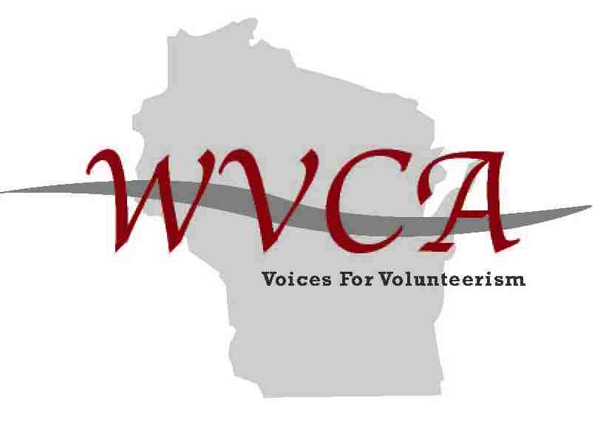

Education Grant Proposal

Date ____________________________________________________________________________
Contact Name _____________________________________________________________________
Affiliate ___________________________________________________________________________
Complete Address ___________________________________________________________________
Phone _________________________ Email _______________________________________________
Date of Training/Conference____________________________________________________________

Please review and answer all questions regarding your proposal.

Criteria Requirements:
1. Must be an Affiliate member in good standing.
2. Each year a set amount will be designated by the current WVCA board to be given out for Affiliates to provide local training. A maximum grant of $300.00 will be awarded to winning proposals. Funds will be given out provided the WVCA budget allows. Educational grant allotment will be reviewed at the end of WVCA Fiscal year.
3. A letter from the current WVCA Vice President will be sent to each Affiliate President/Representative in good standing inviting proposals for the education grant.
4. Each proposal for funds should include who, what, where. What are you needing the funds for and how many anticipated volunteers/staff will be trained at the workshop/presentation? You will also need to support what are the other sources of revenue, and an estimated budget for the event.
5. The WVCA board will review your proposal. Recipients of funds will be chosen at WVCA board meetings (quarterly meetings), and funds will be awarded shortly thereafter.
6. Affiliates receiving funds will be required to list WVCA as a sponsor in their brochure and any other marketing tools. Recipient(s) will be asked to write a newsletter item for the WVCA quarterly newsletter as well as any local opportunities. It will also become a feature in our annual report.
7. Affiliates that have been awarded a grant will be eligible to reapply annually.

Email your proposal and any related materials to: wvcaleadership@gmail.com.

